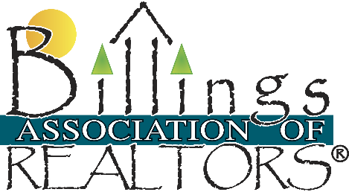
Billings Association of REALTORS®, Inc.
2021 Overland Avenue
Billings, MT 59102
406-248-7145 www.billings.org

To file an ethics complaint against a member of the Billings Association of REALTORS®, Inc, fill out the Ethics Complaint Form #E-1 and refer to a copy of the Code of Ethics and Standards of Practice of the National Association of REALTORS®.
Please complete the form to the best of your ability and return. Generally, we ask that a written description of the case and copies of all documents that will support the case be sent in with the complete form.
Please do not send original documents to our office. Identify the Article or Articles that best describe the nature of the violation. Please note that only the Articles are used in the complaint however the Standards of Practice are named to support the Article.
We hope that we can be of help to you to reach a resolution to your problem.
Email the completed form and written explanation to Mary Grant, Executive Officer at maryg@billings.org
History of the Code of Ethics: http://www.realtor.org/topics/code-of-ethics
2020 Code of Ethics: https://www.nar.realtor/sites/default/files/documents/2020-Code-of-Ethics-and-Standards-of-Practice.pdf
Before you file an Ethics Complaint: http://www.billingsmls.com/member_documents/before-you-file-an-ethics-complaint-brochure-2015-revisions.pdf
Pathways to Professionalism: http://www.billingsmls.com/member_documents/Pathways-to-Professionalism.pdf
Ethics Complaint Form: http://www.billingsmls.com/member_documents/EthicsComplaintForm.pdf
The Code of Ethics Explained in Video: http://www.realtor.org/code-of-ethics/code-of-ethics-pathways-to-professionalism-video-series

About the Training Requirement
REALTORS® are required to complete ethics training of not less than 2 hours, 30 minutes of instructional time within four-year cycles. The training must meet specific learning objectives and criteria established by the National Association of REALTORS®.

Beginning January 1, 2019, all members must complete ethics training of not less than 2 hours, 30 minutes of instructional time with three year cycles. The current cycle ends December 31, 2021.
Training may be completed through local REALTOR® associations or through another method, such as home study, correspondence, classroom courses, or online courses.
- New member training resources
- Existing member training resources
- For more information on the Code of Ethics, click here: https://www.nar.realtor/about-nar/policies/code-of-ethics-and-professional-standards

